**Mobile Sales Dashboard Analysis using Power BI - Project Documentation**

**1. Introduction**

**1.1 Project Overview**

The **Mobile Sales Dashboard Analysis using Power BI** project aims to provide a comprehensive analysis of mobile sales data through an interactive and visually appealing dashboard. The purpose of this project is to enable stakeholders to make data-driven decisions by offering insights into sales performance, customer behaviour, and revenue trends. The dashboard will serve as a central tool for monitoring key performance indicators (KPIs) and identifying areas for improvement in sales strategies.

**1.2 Significance**

In today’s competitive market, businesses need to leverage data to stay ahead. This project is significant because it provides a clear, real-time view of mobile sales data, helping stakeholders understand sales trends, customer preferences, and revenue streams. The dashboard will also help in identifying underperforming areas and optimizing sales strategies.

**1.3 Scope**

The scope of this project includes:

* Analyzing sales data across different regions, product categories, and customer segments.
* Visualizing key metrics such as total revenue, transaction counts, and customer acquisition costs.
* Providing insights into customer demographics, spending patterns, and product preferences.
* Creating an interactive dashboard that allows stakeholders to filter and drill down into specific data points.

**1.4 Stakeholders**

* **Sales Managers**: To monitor sales performance and identify trends.
* **Marketing Teams**: To understand customer behavior and optimize campaigns.
* **Executives**: To make strategic decisions based on sales data.
* **Data Analysts**: To explore data and generate insights.

**2. Project Objectives**

**2.1 Problem Statements**

* Lack of a centralized platform to monitor mobile sales performance.
* Difficulty in identifying key trends and patterns in sales data.
* Inefficient decision-making due to the absence of real-time data insights.

**2.2 Key Goals**

* **Centralized Data Visualization**: Create a single dashboard to visualize all relevant sales data.
* **Real-Time Insights**: Provide real-time insights into sales performance and customer behavior.
* **Identify Trends**: Identify sales trends across different regions, customer segments, and product categories.
* **Optimize Sales Strategies**: Enable stakeholders to optimize sales strategies based on data-driven insights.

**3. Data Sources & Preparation**

**3.1 Description of Datasets**

The project utilizes the following datasets:

* **Sales Data**: Includes transaction details, revenue, and product categories.
* **Customer Data**: Contains customer demographics, income levels, and job profiles.
* **Transaction Data**: Includes transaction counts, amounts, and expenditure types.

**3.2 Data Sources**

* **Internal Databases**: Sales and customer data extracted from the company’s CRM and ERP systems.
* **External Data**: Market trends and competitor analysis data from third-party sources.

**3.3 Data Preparation**

* **Data Cleaning**: Removed duplicates, handled missing values, and corrected inconsistencies.
* **Data Transformation**: Aggregated data to create meaningful metrics such as total revenue, average transaction value, and customer acquisition cost.
* **Data Integration**: Combined multiple datasets to create a unified data model for analysis.

**4. Methodology and Approach**

**4.1 Implementation**

The project was implemented using **Power BI**, a business analytics tool by Microsoft. The implementation involved:

* **Data Modelling**: Creating relationships between different tables (e.g., sales, customers, transactions).
* **DAX Calculations**: Writing DAX formulas to calculate key metrics such as total revenue, transaction counts, and customer acquisition costs.
* **Visualization**: Designing interactive charts, graphs, and tables to represent data.

**4.2 Framework**

The project followed the **CRISP-DM (Cross-Industry Standard Process for Data Mining)** framework:

1. **Business Understanding**: Defined project objectives and stakeholder requirements.
2. **Data Understanding**: Explored and cleaned the datasets.
3. **Data Preparation**: Transformed and integrated data for analysis.
4. **Modelling**: Created data models and calculated key metrics.
5. **Evaluation**: Validated the dashboard with stakeholders.
6. **Deployment**: Published the dashboard for stakeholders to use.

**4.3 Methods Applied**

* **Descriptive Analytics**: Used to summarize historical sales data.
* **Diagnostic Analytics**: Applied to identify reasons behind sales trends.
* **Predictive Analytics**: Used to forecast future sales based on historical data.

**4.4 Assumptions and Limitations**

* **Assumptions**:
  + Data provided is accurate and up-to-date.
  + Customer behaviour patterns remain consistent over time.
* **Limitations**:
  + Limited by the quality and completeness of the data.
  + Predictive analytics may not account for unforeseen market changes.

**5. Dashboard Design & Features**

**5.1 Explanation of the Power BI Dashboard**

The dashboard is designed to provide a comprehensive view of mobile sales data. It includes the following key features:

* **Interactive Filters**: Allows users to filter data by region, product category, and time period.
* **Key Metrics**: Displays total revenue, transaction counts, and customer acquisition costs.
* **Visualizations**: Includes bar charts, pie charts, line graphs, and tables to represent data.

**5.2 Key Metrics**

* **Total Revenue**: Sum of all sales transactions.
* **Transaction Count**: Total number of transactions.
* **Customer Acquisition Cost**: Cost of acquiring new customers.
* **Revenue by Product Category**: Breakdown of revenue by different product categories.
* **Revenue by Region**: Sales performance across different regions.

**5.3 Visualizations**

* **Bar Charts**: Used to compare sales performance across regions and product categories.
* **Pie Charts**: Used to show the distribution of revenue by customer segments.
* **Line Graphs**: Used to visualize sales trends over time.

**Dashboard Preview**

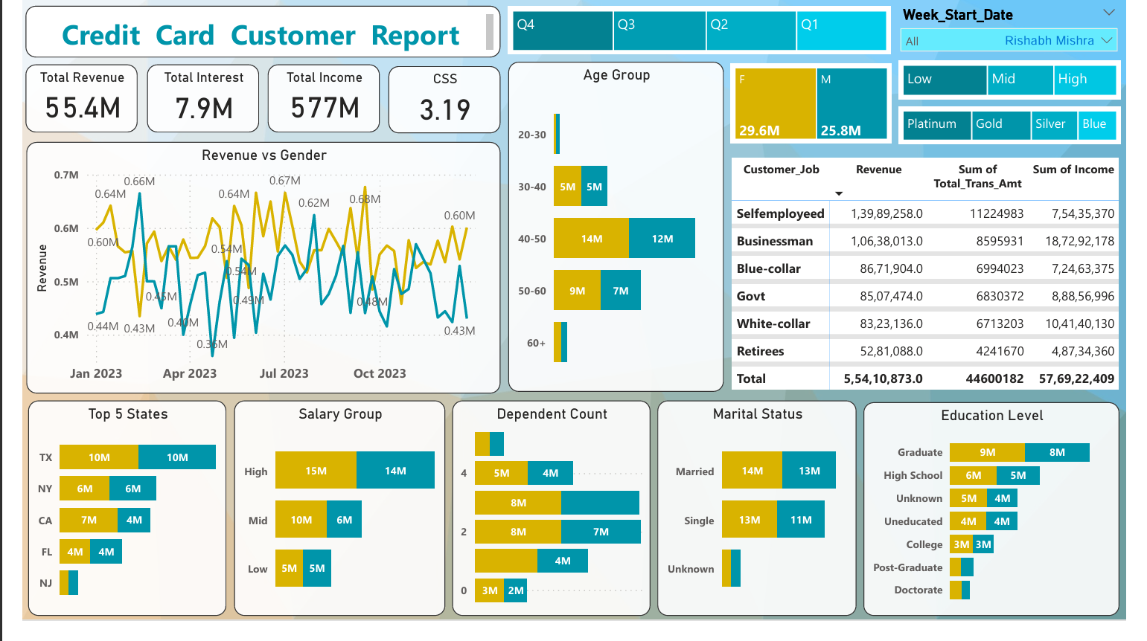

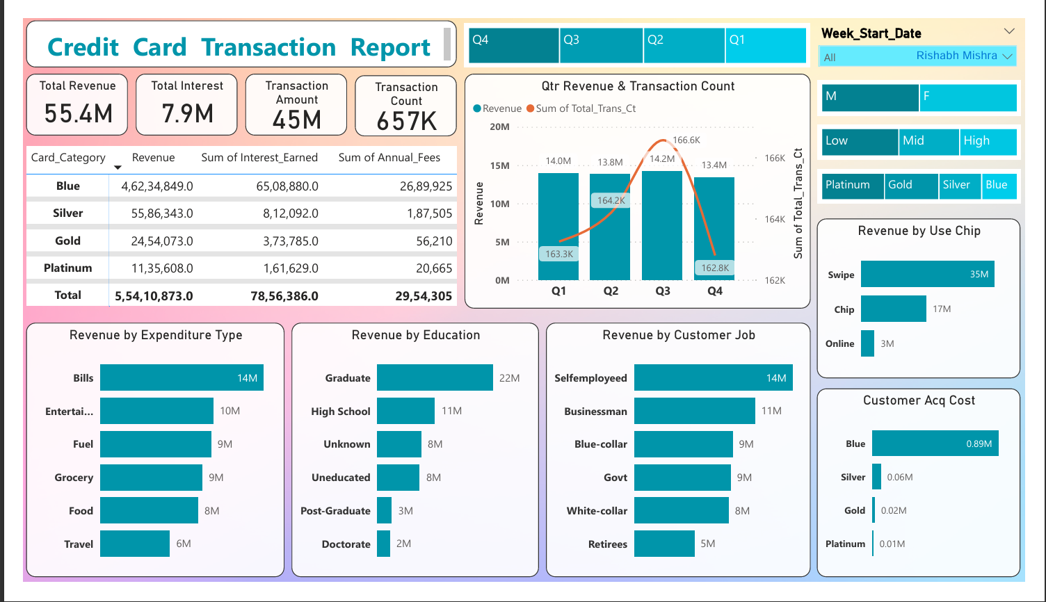

**6. Insights & Analysis**

**6.1 Key Findings**

**1. Customer Demographics & Segmentation**

* Gender Distribution: Slight male dominance (Males: 29.6M, Females: 25.8M).

**Age Group Distribution:**

* The 30-40 age group dominates the customer base (14M customers), followed by 40-50 (9M) and 20-30 (5M).
* Customers aged 60+ (7M) present a good market opportunity for specialized financial products.

**Income Segments:**

* High-income earners (15M customers) form the largest segment.
* Mid-income (10M) and low-income (5M) groups are also significant.

**Education Level:**

* Graduates (9M) and post-graduates (8M) hold the majority of credit cards.
* Uneducated and high-school pass-outs (6M and 5M, respectively) are underrepresented in credit card ownership.

**2. Revenue & Spending Trends**

* Total Revenue: ₹55.4M, with a total transaction amount of ₹45M.

**Revenue by Expenditure Type:**

* Bills (₹14M), Entertainment (₹10M), Fuel (₹9M), Grocery (₹9M), Food (₹8M), Travel (₹6M).
* Bills & Entertainment contribute the highest revenue share.

**Transaction Type Preference:**

* Swipe-based transactions (₹35M) are the most popular, followed by chip (₹17M) and online (₹3M).
* Low online transaction value suggests a need for digital adoption campaigns.

**3. Credit Card Category Performance**

* Blue Cards generate the highest revenue (₹4.62M) but have high acquisition costs (₹0.89M).
* Platinum Cards have the lowest customer acquisition cost (₹0.01M) but contribute the least revenue (₹11.35M).
* Gold and Silver Cards are mid-tier performers, generating moderate revenue at balanced costs.
* Total Interest Earned: ₹7.9M with an opportunity to increase it by promoting premium cards and higher credit utilization.

**4. Quarterly Revenue Trends & Customer Engagement**

* Revenue remains relatively stable across quarters:
* Q3 had the highest revenue (₹14.2M), while Q4 had the lowest (₹13.4M).
* Transaction Count is consistent (162K-166K per quarter), indicating a loyal user base.
* Seasonal spending variations exist, but no extreme fluctuations.

**6.2 Business Insights**

**Targeted Customer Segments:**

* The 30-40 age group and high-income earners are key contributors to revenue.
* The 60+ age group and lower-income earners are underutilized market segments.

**Opportunities to Increase Digital Transactions:**

* Swipe-based transactions dominate (₹35M), while online spending is only ₹3M.
* Online and mobile payment adoption must be promoted through incentives.

**Credit Card Category Optimization:**

* The Blue Card category has high revenue but also high acquisition costs.
* Gold and Platinum cards need better promotion to boost revenue contribution.

**Spending Behaviour Insights:**

* Bills & Entertainment are the top spending categories.
* Fuel and Grocery spending indicate dependency on credit cards for essentials.

**6.3 Recommendations & Strategic Actions**

**1. Increase Digital Payment Adoption**

* 📌 Problem: Online transactions contribute only ₹3M, far below swipe-based transactions.  
  ✅ Action Plan:
* Introduce cashback and reward programs for online transactions.
* Partner with e-commerce platforms for exclusive cardholder discounts.
* Offer low-interest EMIs on online purchases to encourage high-value spending.

**2. Optimize Credit Card Portfolio & Upsell Premium Cards**

* 📌 Problem: Blue Cards contribute the highest revenue but have high acquisition costs.  
  ✅ Action Plan:
* Shift marketing focus toward Gold & Platinum cards, which have better cost-to-revenue ratios.
* Provide exclusive perks like airport lounge access, travel insurance, and cashback to attract high-spending users.
* Run targeted promotions for Business Owners & Self-employed professionals, as they are major revenue contributors.

**3. Expand Market Reach in Underpenetrated Segments**

* 📌 Problem: Customers aged 60+ and low-income groups have lower credit card ownership.  
  ✅ Action Plan:
* Design senior citizen-friendly credit cards with medical and travel benefits.
* Offer basic credit cards with lower fees to encourage adoption in the low-income segment.
* Partner with government financial literacy programs to promote credit awareness.

**4. Boost Customer Engagement with Spending-Based Rewards**

* 📌 Problem: Revenue fluctuations across quarters indicate low spending engagement during certain periods.  
  ✅ Action Plan:
* Run seasonal and festival-based promotional campaigns with extra rewards.
* Implement a tiered reward system, offering higher cashback for higher spending.
* Introduce subscription-based reward programs, incentivizing frequent usage.

**5. Strengthen Geographic Expansion Strategy**

* 📌 Problem: Most customers are concentrated in Texas, California, Florida, and New York.  
  ✅ Action Plan:
* Expand marketing campaigns into underpenetrated states with a growing economy.
* Collaborate with local businesses and banks to provide regional discounts.
* Offer geo-targeted incentives, such as cashback on city-specific transactions.

**6.4**🚀 **Expected Impact of Implementing These Strategies**

**📈 Revenue Growth:**

* Increasing online transactions and premium card adoption can boost revenue by 15-20%.
* Expanding credit card penetration in the 60+ age group and low-income segment can bring new users and steady transactions.

**🎯 Improved Customer Retention & Loyalty:**

* A better reward system will encourage higher spending and repeat transactions.
* Senior-friendly and low-income-targeted products will enhance financial inclusion and long-term engagement.

**🏆 Market Expansion & Brand Leadership:**

* Penetration in new states will increase market share and visibility.
* Business-owner-focused credit cards will strengthen relationships with high-net-worth individuals.

**7. Challenges & Solutions**

**7.1 Challenges**

* **Data Quality Issues**: Incomplete and inconsistent data.
* **Complex Data Integration**: Combining multiple datasets with different structures.
* **Stakeholder Alignment**: Ensuring all stakeholders agreed on the key metrics and visualizations.

**7.2 Solutions**

* **Data Cleaning**: Used Power Query to clean and transform data.
* **Data Modelling**: Created a unified data model to integrate different datasets.
* **Stakeholder Collaboration**: Conducted regular meetings to align on project goals and deliverables.

**8. Conclusion & Future Enhancements**

**8.1 Conclusion**

The **Mobile Sales Dashboard Analysis using Power BI** project successfully delivered an interactive and insightful dashboard that provides stakeholders with a clear view of mobile sales performance. The dashboard enables data-driven decision-making and helps identify key trends and opportunities for growth.

**8.2 Future Enhancements**

* **Advanced Predictive Analytics**: Incorporate machine learning models to forecast sales more accurately.
* **Real-Time Data Integration**: Integrate real-time data feeds for up-to-the-minute insights.
* **Mobile Compatibility**: Develop a mobile-friendly version of the dashboard for on-the-go access.
* **Customer Segmentation**: Add more granular customer segmentation to better understand different customer groups.

This documentation provides a comprehensive overview of the **Mobile Sales Dashboard Analysis using Power BI** project, outlining its objectives, methodology, and key findings. The dashboard is a powerful tool for stakeholders to monitor sales performance and make informed decisions.